|  |  |
| --- | --- |
| Name : Mieca Cunanan | Section : BSIT 3C |
| Assignment No : 3 | Submission Date : April 6, 2024 |
| **Assignment Title: Number Guessing Game** | |

**HTML FILE**

<!DOCTYPE html>

<html lang="en">

<head>

<meta charset="UTF-8">

<meta name="viewport" content="width=device-width, initial-scale=1.0">

<title>Number Guessing Game</title>

<link rel="stylesheet" href="styles.css">

</head>

<body>

<div class="container">

<h1>Number Guessing Game</h1>

<p>Guess a number between 1 and 10:</p>

<input type="number" id="guess" min="1" max="10">

<button id="submit" onclick="checkGuess()">Submit Guess</button>

<p id="message" class="message"></p>

</div>

<script src="script.js"></script>

</body>

</html>

**CSS FILE**

body {

font-family: Arial, sans-serif;

text-align: center;

background-color: #f2f2f2;

}

.container {

max-width: 400px;

margin: 0 auto;

padding: 20px;

background-color: #fff;

border-radius: 10px;

box-shadow: 0 0 10px rgba(0, 0, 0, 0.1);

}

h1 {

color: #212a52;

}

input[type="number"] {

padding: 10px;

width: 100%;

margin-bottom: 10px;

}

button {

padding: 10px 20px;

background-color: #007bff;

color: #fff;

border: none;

cursor: pointer;

margin-top: 10px;

border-radius: 5px;

}

button:hover {

background-color: #0056b3;

}

p {

color: #888;

margin-bottom: 10px;

}

.message {

margin-top: 20px;

font-weight: bold;

color: #333;

}

**JS FILE**

const randomNumber = Math.floor(Math.random() * 10) + 1;

// Function to check the user's guess

function checkGuess() {

const guess = parseInt(document.getElementById("guessInput").value);

// Check if the guess is a valid number between 1 and 10

if (isNaN(guess) || guess < 1 || guess > 10) {

document.getElementById("message").textContent = "Invalid input: Please input a number between 1 and 10.";

return;

}

// Check if the guess is correct

if (guess === randomNumber) {

document.getElementById("message").textContent = Congratulations! You've guessed the correct number ${randomNumber}!;

} else if (guess < randomNumber) {

document.getElementById("message").textContent = "Too low! Try again.";

} else {

document.getElementById("message").textContent = "Too high! Try again.";

}

}

</script>

function showMessage(message) {

document.getElementById('message').textContent = message;

}

function disableInput() {

document.getElementById('guess').disabled = true;

document.getElementById('submit').disabled = true;

}

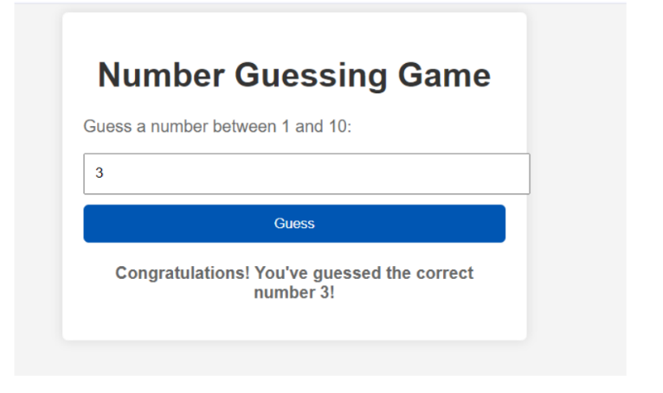**SCREENSHOT**



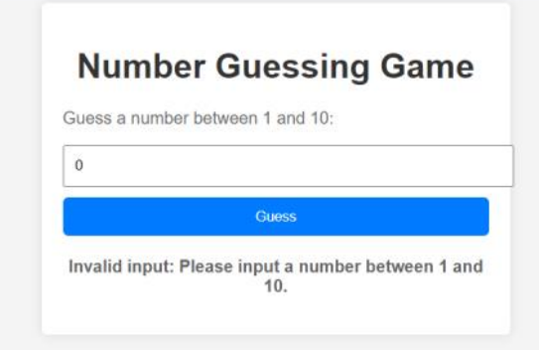

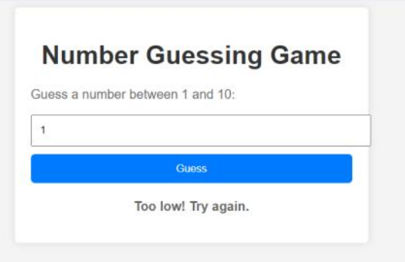

**Dictionary:**

* IsNaN - The isNaN() function determines whether a value is NaN, first converting the value to a number if necessary.
* Math.floor() - Math. floor() is a JavaScript method that returns the largest integer less than or equal to a given number. It basically rounds down a number to its nearest integer.
* Math.random() - Math.random() static method returns a floating-point, pseudo-random number that's greater than or equal to 0 and less than 1, with approximately uniform distribution over that range